# CMPE537 Project 2

### Git-Repo

<https://github.com/batdora/boun_computer_vision_project_2>

CMPE537 Project 2 1

Git-Repo 1

Paris Initial (15 point correspondences) 3

Experiments for CMPE Building and North Campus (15 point correspondences) 3

CMPE Building 3

First Out Then Middle 3

Left to Right 3

Middle-Out 3

North Campus 4

First Out Then Middle 4

Left to Right 4

Middle Out 4

Notes 4

CMPE 4

North Campus 4

Left to Right 5

Correspondence Effects 6

Base (15 Points) 6

No Normalization 6

Noise Sigma 1 6

Noise Sigma 3 6

Noise Sigma 5 7

Only 5 Points (chosen randomly) 7

Wrong Points (15 points + 5 wrong points) 7

## Paris Initial (15 point correspondences)

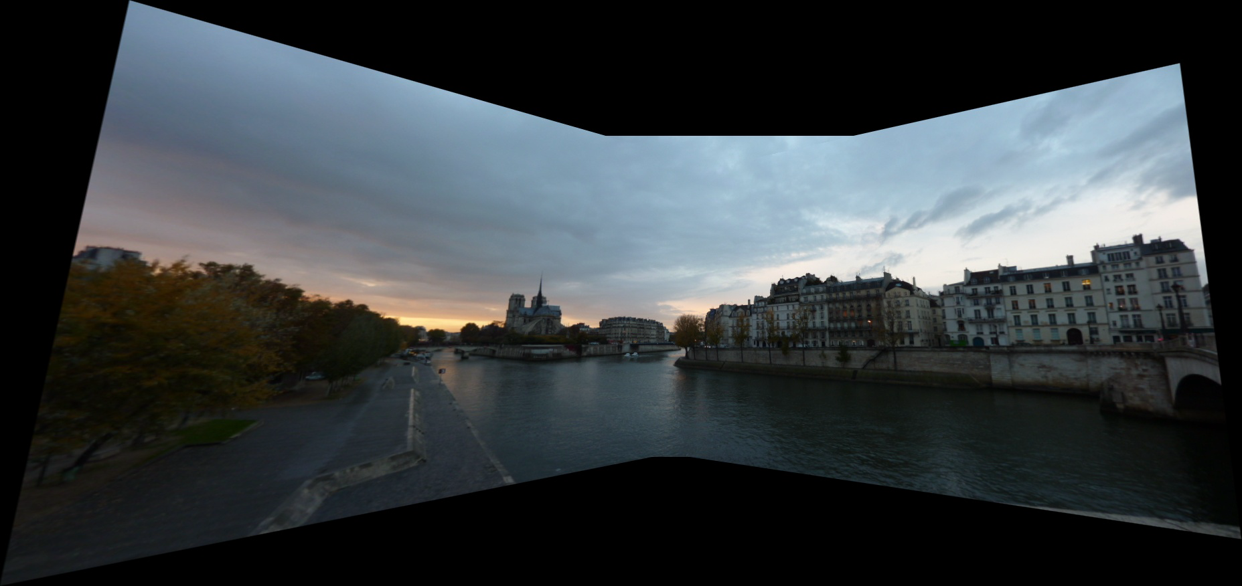

## Experiments for CMPE Building and North Campus (15 point correspondences)

### CMPE Building

#### First Out Then Middle

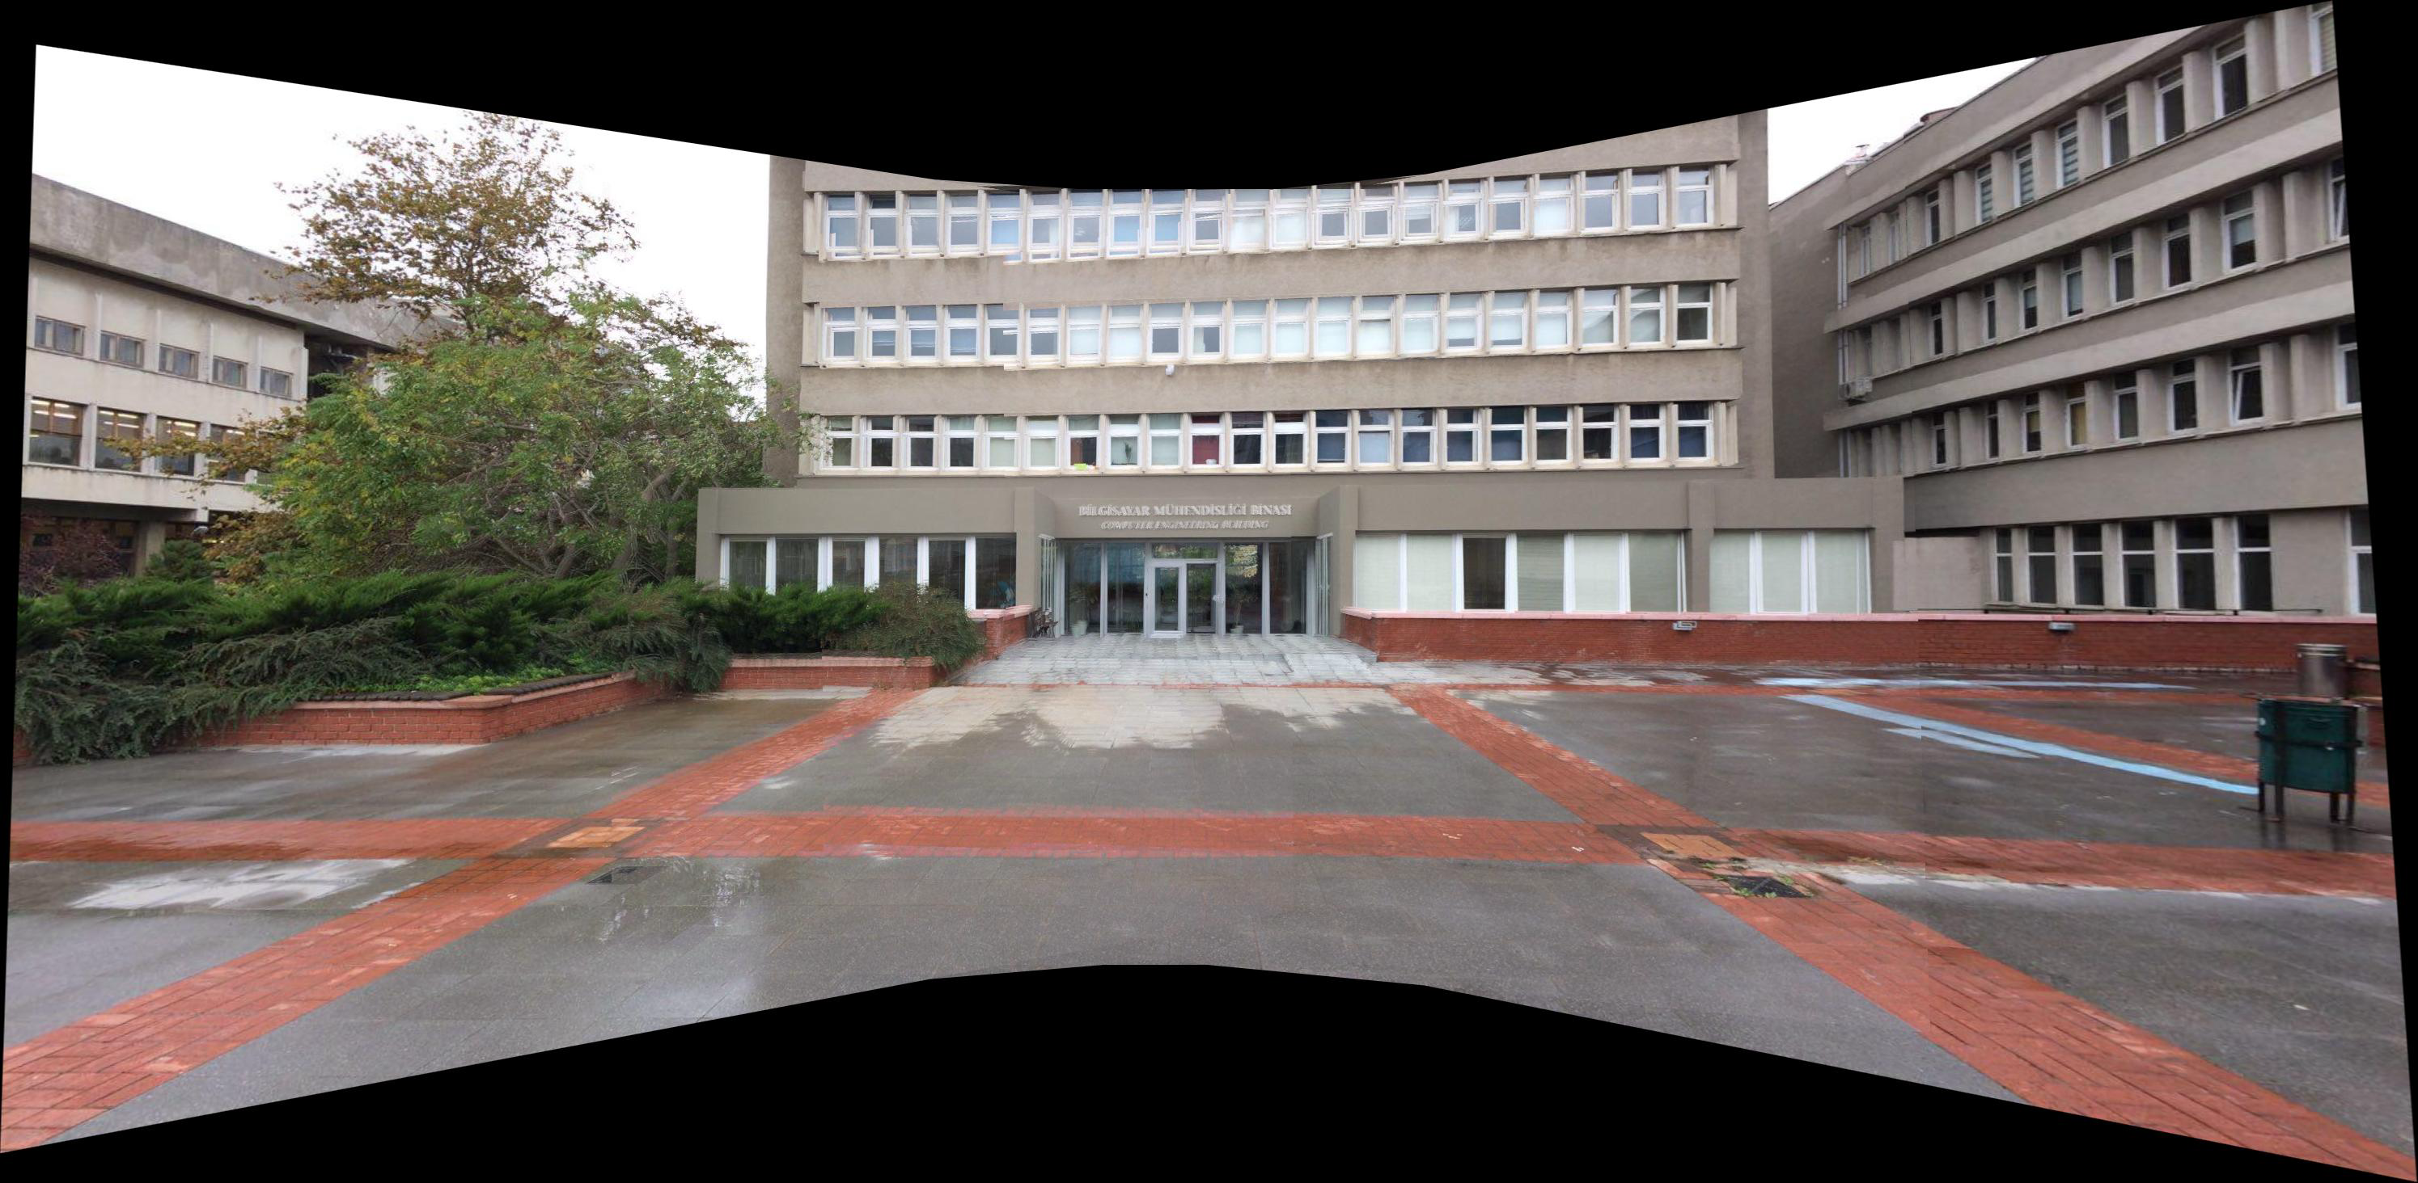

#### Left to Right

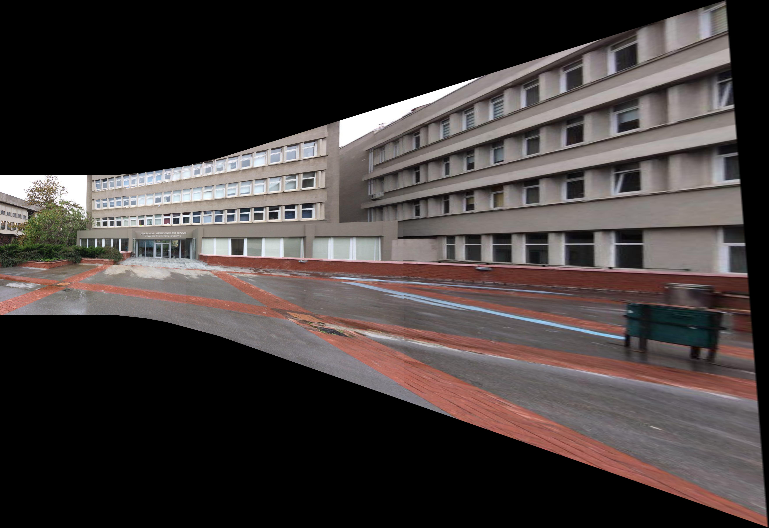

#### Middle-Out



### North Campus

#### First Out Then Middle

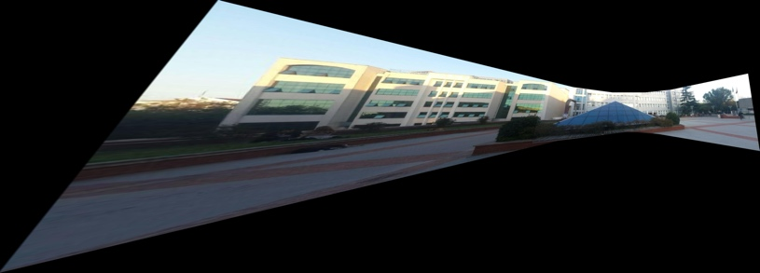

#### Left to Right

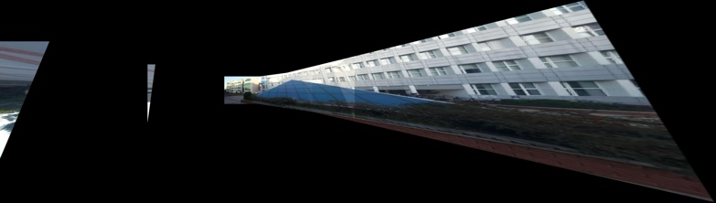

#### Middle Out

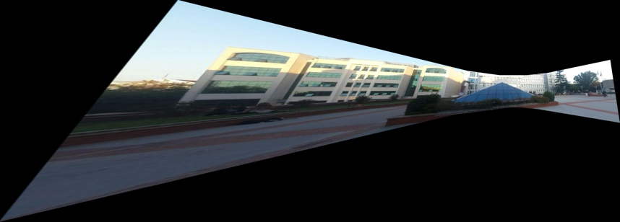

### Notes

#### CMPE

The middle out and first out then middle approaches turned out very good. Some windows appear misaligned but overall its still very acceptable.

#### North Campus

For the North Campus, the warping resulted in a very warped leftmost image. The mosaics were examined to see the issue. Below is the Mosaic left (left1 + left2):

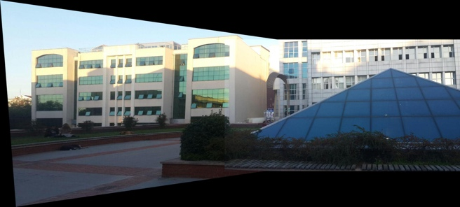

And here is Mosaic right (right1 + right2):

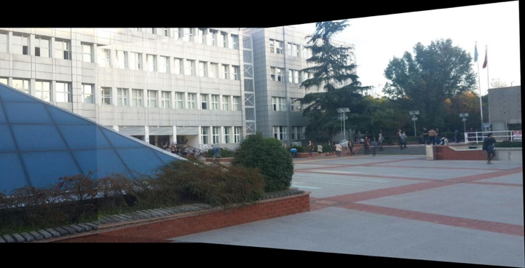

It is clear that rightmost images are better aligned to each other compared to leftmost. It can be understood by the intersection line consuming most of both images in the rightmost and only the end in the leftmost.

And here is the middle mosaic (left1+middle+right1):

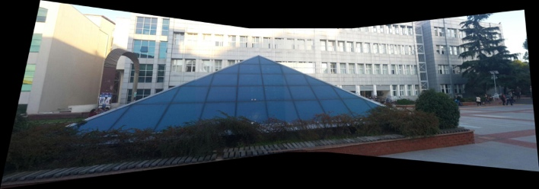

The middle mosaic seems very well balanced for each side. Overall when all of them are combined (either middle out or first out then middle), left2 image becomes very less aligned compared to all other images; thus it gets warped incredibly.

#### Left to Right

It can be clearly seen that left to right stitching results in a very bad image for both. In CMPE example it just results in a very misshaped warped image, but in the North Campus example, the rightmost image (right2) fails to even get stitched due to being pushed out of the frame. Various methods for frame fitting and padding were tried, all resulted in failure so weren’t shared in this report.

## Correspondence Effects

#### Base (15 Points)

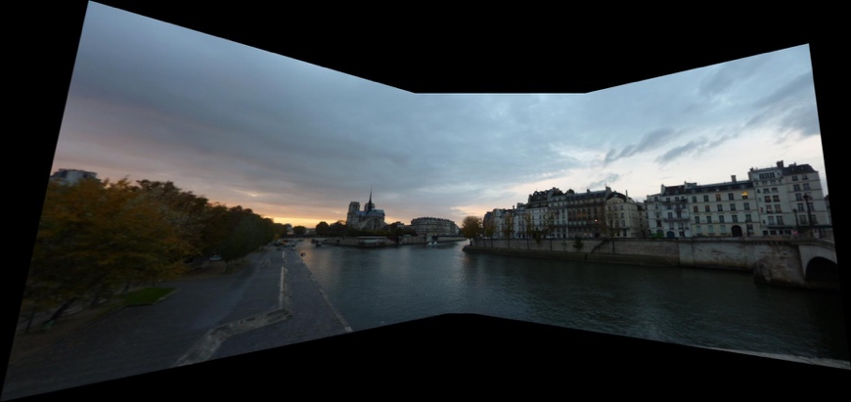

#### No Normalization

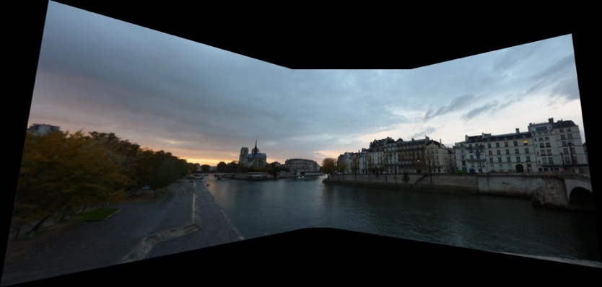

#### Noise Sigma 1

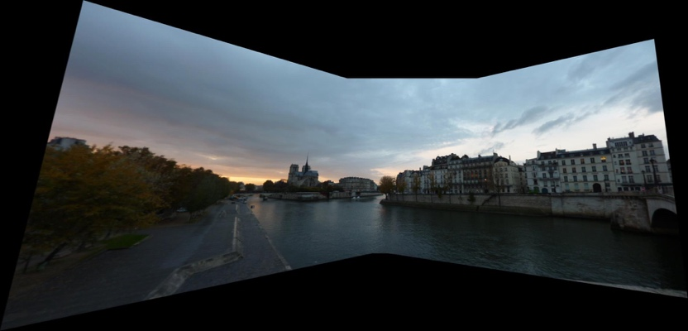

#### Noise Sigma 3

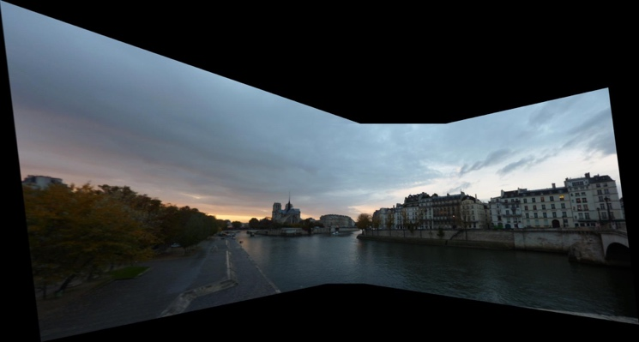

#### Noise Sigma 5

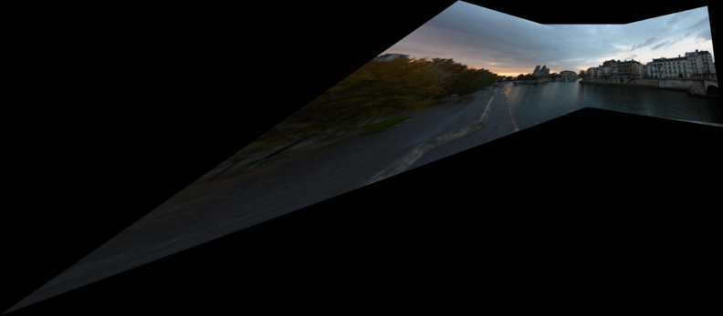

#### Only 5 Points (chosen randomly)

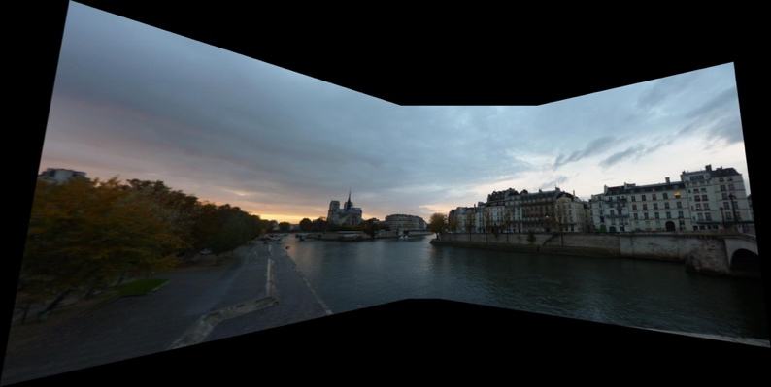

#### Wrong Points (15 points + 5 wrong points)

